Data visualizations

Name of student

Name of professor

University

Course

Date

**Dataset description**

The dataset obtained from this analysis from the FRED website is that of the unemployment rates along the years cutting across the years since 1948 to 2021. The dataset contains a total of 889 instances /occurrences. This data has two column variables; the date variable and the rate of unemployment variable. A preview of the dataset indicates below:

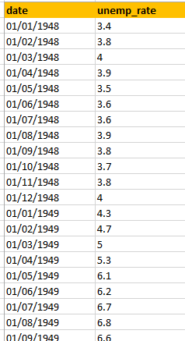

Then a visual presentation of the dataset indicates the following graphical analysis. The unemployment rate seems to be varying across the years from 1948 to 2020. The rate was highest during the early 1980s and in 2011, 2013. Overall, the relationship between the rates of unemployment is not very strong, though there is an indication that unemployment has been and a yearly occurrence across the years.

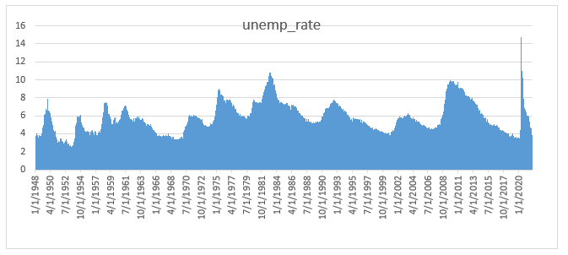

A correlation analysis done between the years of unemployment and the unemployment rates indicates the below:

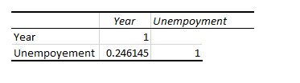

There is a strong indication that unemployment will exist in as the years go by, since this is what has been shown above in the presentation and such, this strong relationship is presented by 1. Overall, there is positive relationship again between the years of unemployment and the unemployment rate.

This correlation value is given by a value of 0.246. Even though it’s a positive value, it’s generally a weak positive relationship. Given the fact that as the years pass by, the unemployment rate does not pick a strong line of best fit, although it’s a fact that unemployment has been on the rise and this is something that can lay confidence that unemployment shall still be there over the years to come.